19.23: 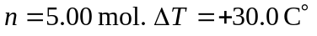

- For constant p,

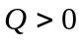 so heat goes into gas.

- For constant V,

Q > 0 so heat goes into gas.

- For constant p,

Q > 0 so heat goes into gas.

